**CH401- MODULE 1**

**DAY 1 ACTIVITY SHEETS**

**NAME: DELA ROSA, BREA ELLYSSE E.**

**SECTION: GRADE 11- FR. BECKER B**

**DATE: JULY 10, 2020**



**Student Activity 1:** PICTURE ANALYSIS

The picture that you see at the right is one of the public ministries of Jesus. Take a closer look and answer the questions below.

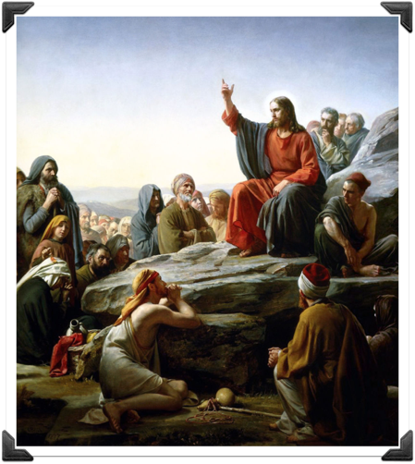

**Guide Questions**

1. What does this image tell you?

2. Can you identify yourself in any of the characters in the picture? Describe briefly.

3. How is the picture connected with the title of the lesson?

https://images.app.goo.gl/T1wxpjJVFo3KxGve8

**1.** The Sermon on the Mount. The Sermon on the Mount is by far Jesus' longest explanation of what it looks like to live as His follower and to serve as a member of God's Kingdom. In many ways, Jesus' teachings during the Sermon on the Mount represent the major ideals of the Christian life.

**2.**  The character that identity myself is the one who mourn their sin, the one who also recognize the comfort when they find forgiveness in Jesus. Because I always find comfort in Jesus when I seek for forgiveness.

**3.**  The Public Ministry of Jesus is included in the lesson and when Jesus delivered the Sermon on the Mount it was the inauguration of his public ministry.



**Activity 2:** Make a timeline of the important events that happen from the beginning of Jesus’ public ministry until the commissioning of the Apostles. Draw a symbol of the event and describe it briefly. Use the template provided.







His Baptism

Jesus’ baptism is important because

it symbolized the sinners’ baptism into

the righteousness of Christ, dying with

him and rising free from sin and able to

walk in the newness of life



He Cleanses out the temple

It tells about of Jesus expelling the

merchants and the money changers

the temple

Jesus Crucifixion and Death

It is important especially for Christians

to let them know that God sacrificed

Jesus, His only son to atone for the sins

of humanity.



The Resurrection of Jesus

It is important because it proves to us 

that forgiveness is real

Jesus and His ascension

It tells us that Jesus had really overcome

death. He wasn’t just resurrected to die again,

but to live forever.